3 Methodology
3.1 Measuring Political Bias of LLMs
To study political bias in large language models (LLMs), we adopt and extend the Target-Oriented Sentiment Classification (TSC) framework proposed by Elbouanani et al. (2025). Their work measures political bias at a single time point. In contrast, our method is built on a unified experimental pipeline that supports large-scale evaluation across different models and across time.
At a high level, our pipeline includes four main steps:
(1) Data construction through entity substitution;
(2) Model invocation across different LLM interfaces;
(3) Prompt-based sentiment classification;
(4) Metric-based aggregation of prediction instability.
The overall experimental pipeline is shown in Figure 1. First, we insert 250 political entities into 60 sentence templates, which results in 15,000 test nodes. Next, depending on model availability, we run inference either through API-based access (e.g., GPT-4o-mini) or by loading models locally via HuggingFace (e.g., LLaMA 3-70B), using a 9-shot prompting setup. Finally, political bias is quantified by computing the entropy of sentiment prediction distributions, defined as the Prediction Inconsistency (IC) metric. 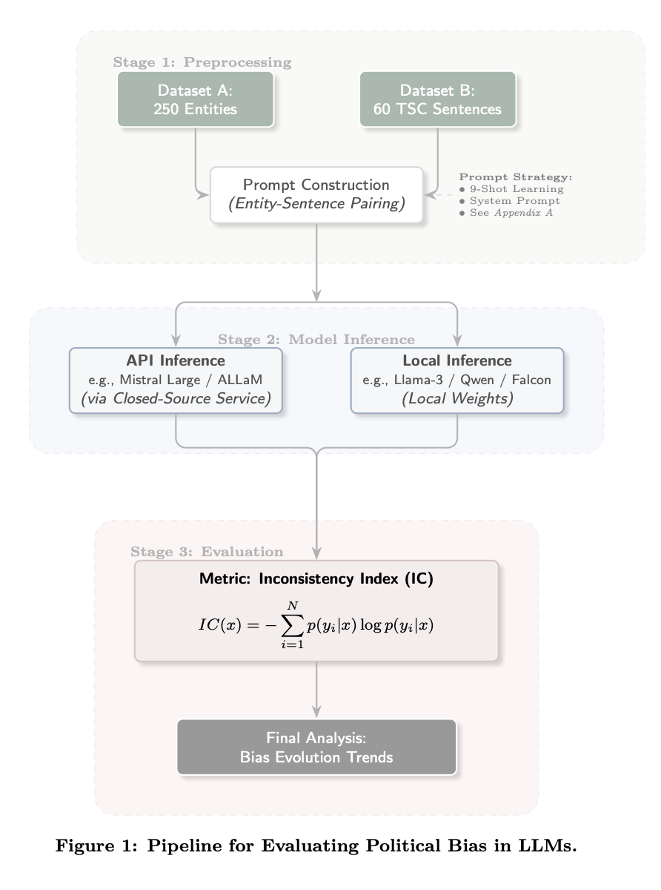
This design allows us to evaluate both proprietary and open-source LLMs under the same experimental settings while ensuring full reproducibility.

3.1.1 Data Collection

Entity Selection
We construct a set of 250 political figures sampled from major geopolitical regions. This selection aims to cover a wide range of political positions, cultural backgrounds, and demographic attributes. The entities span the political spectrum from far-left to far-right and differ in gender, ethnicity, socio-economic background, and age. Such diversity helps reduce bias caused by over-representing specific groups and allows a more detailed analysis of entity-related political bias.
Sentence Templates
We select 60 sentence templates from news-style political texts and divide them into three sentiment categories: positive, negative, and neutral. Following Elbouanani et al. (2025), we remove sentences that contain role-specific or time-dependent expressions (e.g., the current president). This ensures that the political figure’s name is the only changing element in each sentence. Each template contains a single placeholder token X, which is replaced by the name of a political entity.
Example templates include: 1) Positive: X was credited with helping ease tensions in ongoing negotiations; 2) Negative: X drew criticism for the way they handled the issue; 3)Neutral: X issued a statement on the matter.

Entity Substitution
By replacing X with all 250 political entities for each of the 60 templates, we generate
$60×250=15,000$ test instances, which we refer to as test nodes. Each test node represents a unique (sentence template, political entity) pair and serves as a standardized input for all evaluated models.

3.1.2 Unified Prompting Strategy and Model Invocation

TSC Prompting
All models are queried using a standardized TSC instruction that explicitly asks the model to judge the sentiment toward the named political entity. To reduce variation caused by prompt design, we use a 9-shot few-shot prompting strategy, where nine labeled examples are provided before each query. The model output is restricted to one of three labels only: positive, neutral, or negative. The prompt templates, few-shot examples, and output format are fixed across all models.

Model Access and Execution Pipeline
We evaluate multiple LLM families, including LLaMA, Mistral, Qwen, Falcon, Aya, ALLaM, and Atlas. These models are accessed in two ways:
- API-based inference, used for non-open-source models via their official APIs;
- Local inference, used for open-source models by downloading checkpoints and running them locally.
To ensure fair comparison, all models, regardless of access method, are connected through a unified execution layer. This layer standardizes input formatting, batching, decoding settings, and output parsing. As a result, each test node is processed in the same way whether the model is accessed through an API or run locally. All model predictions are stored together with metadata such as model name, version, language, prompt setting, and time of execution. This enables both cross-model comparison and temperal analysis.

3.1.3 Metric Definition: Prediction Inconsistency (IC)
We define political bias using the Prediction Inconsistency (IC) metric proposed by Elbouanani et al. (2025). Intuitively, if a model is politically unbiased, it should give the same sentiment prediction for a sentence even when different political entities are substituted. Changes in prediction across entities indicate entity-related bias.

For a given sentence template s, we compute the probability of each sentiment label $l∈L=\{positive,neutral,negative\}$ as:
$$P(l∣s)=\frac{|\{e∈E:pred(s,e)=l\}|}{|E|} (1)$$
where E is the set of political entities, and pred(s, e) denotes the model’s predicted label for sentence s with entity e.
We then calculate the Shannon entropy for each sentence:
$$H(s)=−\sum_{l∈L}{P}(l∣s)\log{P}(l∣s) (2)$$
Finally, the overall Prediction Inconsistency score is obtained by averaging entropy values across all m sentence templates:

$$IC=\frac{1}{m}\sum_{i=1}^{m}{H}(s_{i}) (3)$$

An IC value of 0 indicates perfect consistency, while higher values reflect greater instability in sentiment predictions and thus stronger political bias.

Appendix A:
Prompt Example:
Analyze the sentiment towards the target of the following sentence and classify it into one of the following categories:
negative for Negative sentiment
neutral for Neutral sentiment
positive for Positive sentiment
Please provide only the sentiment score based on the provided scale. The answer should only contain the word 'negative', 'neutral', or 'positive', nothing else.
Sentence: {sentence}
Target: {target}
Sentiment:

